Git and GitHub task 02

1. Install Git
Download from https://git-scm.com/downloads
Check installation: git –version
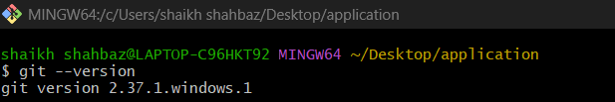

2. Create a repository in GitHub with README.md and .gitignore
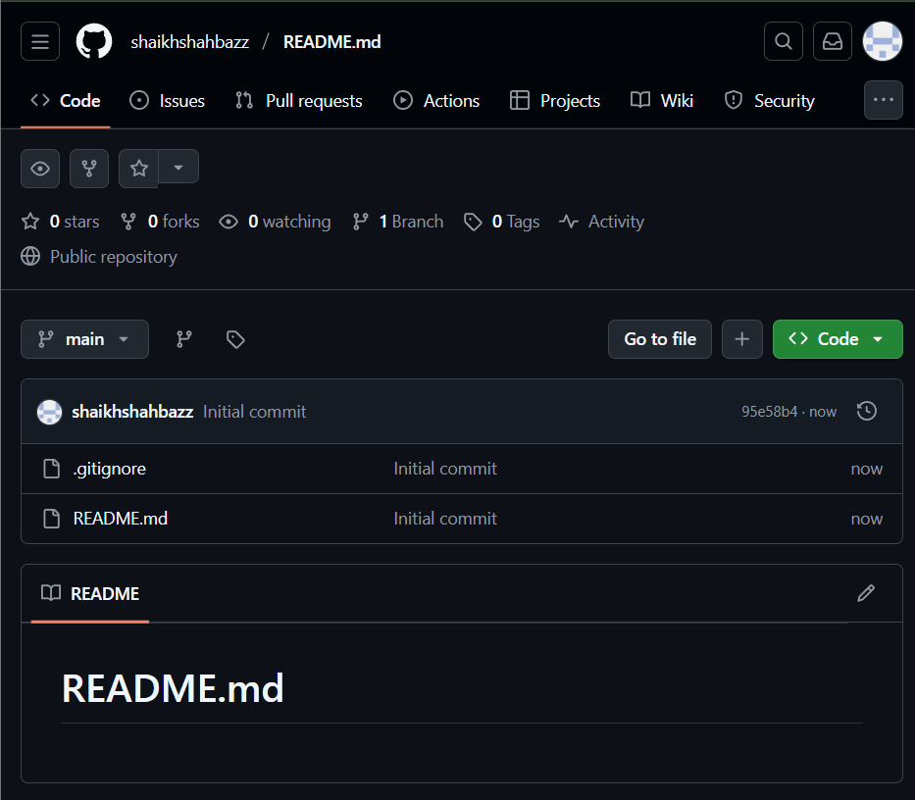

3. Clone the created repository to local
To clone the repository to local
git clone <ssh url from github>
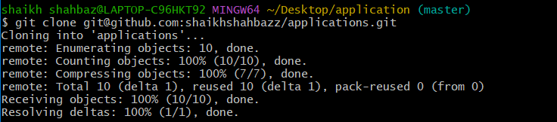

4. Create two files in local repository
file1 and file2 are created in local repository
touch file1 file2
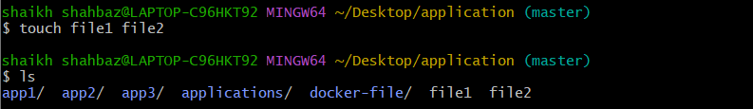

5. Commit two files and push to central repository
To add files to central repository, we need to add files to tracking area
git add .
Then commit the files and add commit message
git commit -m “added two files”
Then push the files to central repository
git push -u origin master
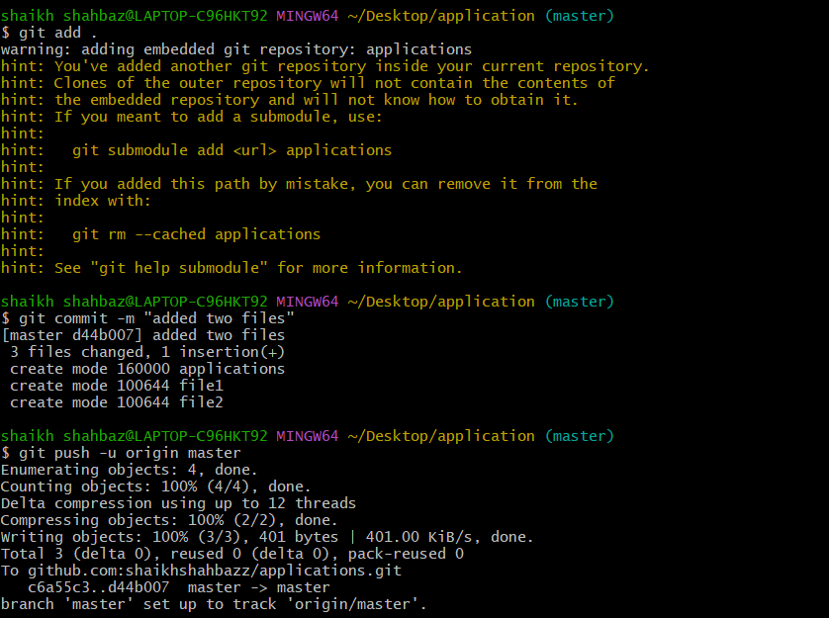

6. Create a branch in local and create a sample file and push to central
To create a branch in local the command is
git checkout -b sample-branch
-b is to create a branch and switch to it
sample-branch is local branch name
To add a sample file to it use
touch sample-file ---- File will be created named sample-file
Then add and commit the sample-file
git add .
git commit -m “added sample file”
Then push to central repository in git hub
git push -u origin sample-branch
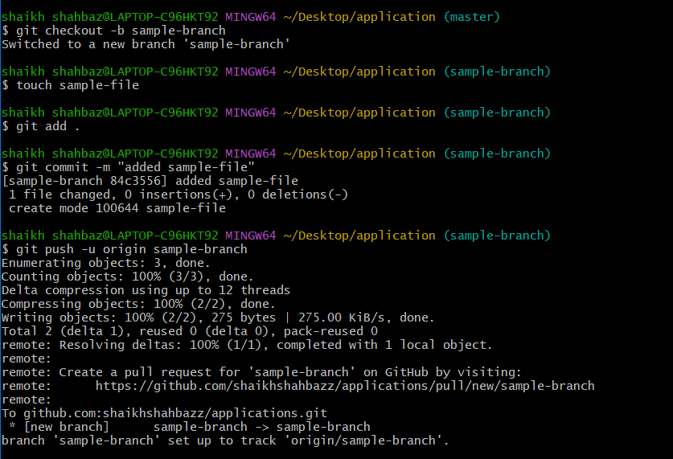
We can see in central repository
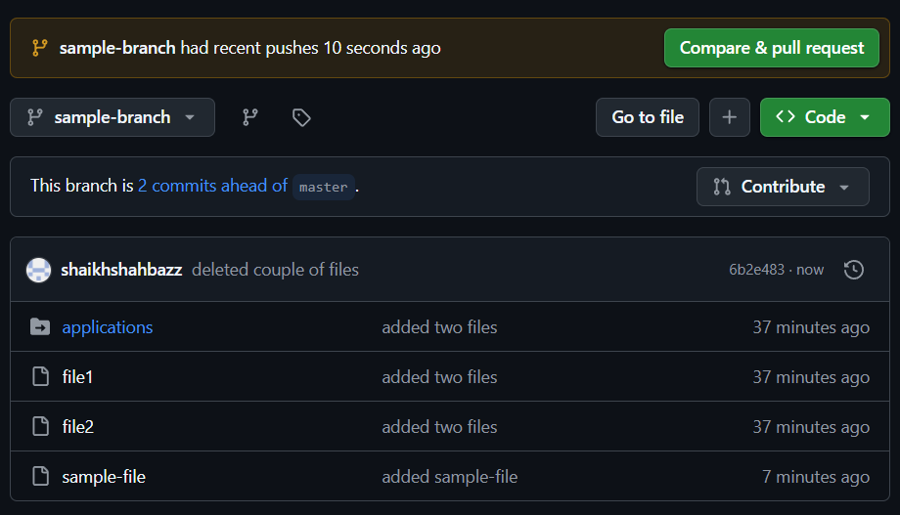

7. Create a branch in git hub and clone that branch to local
Created a branch in git hub named as new-branch
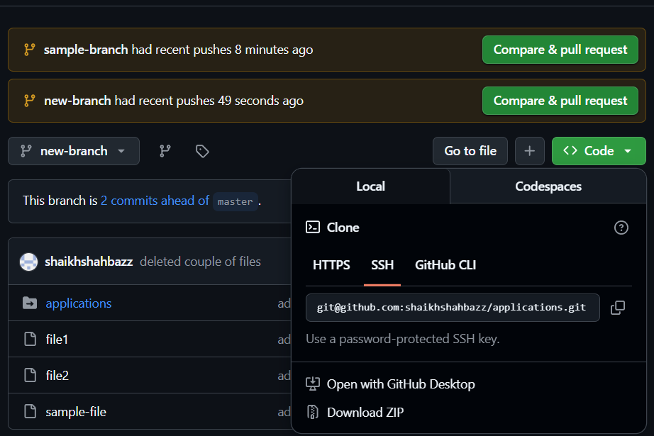

To clone the specific branch in local machine
git fetch
git checkout new-branch
Now it shows we are in new-branch
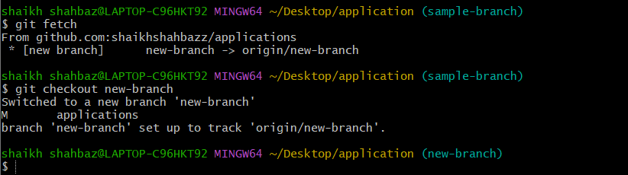

8. Merge the created branch with master in git local

Switch to master branch
git checkout master
Merge the created branch with master branch
git merge new-branch
git push -u origin master
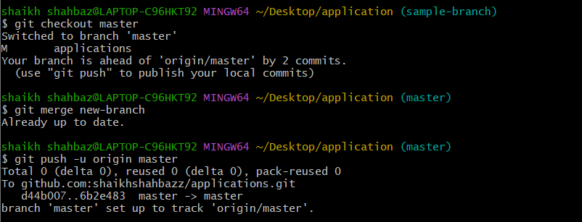

9.Merge the created branch with master in github by sending a pull request
Switch to created branch
git checkout new-branch
Create a new empty file for pull request
Touch prfile ----- pull request file
Add to tracked file and then commit the file
git commit -m “created file for pull request”
Now push to git hub
git push -u origin new-branch

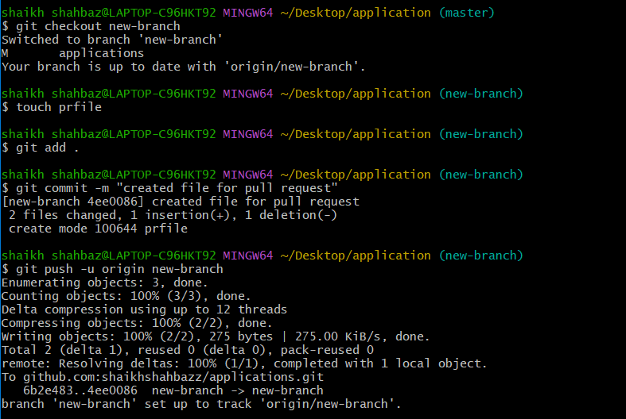

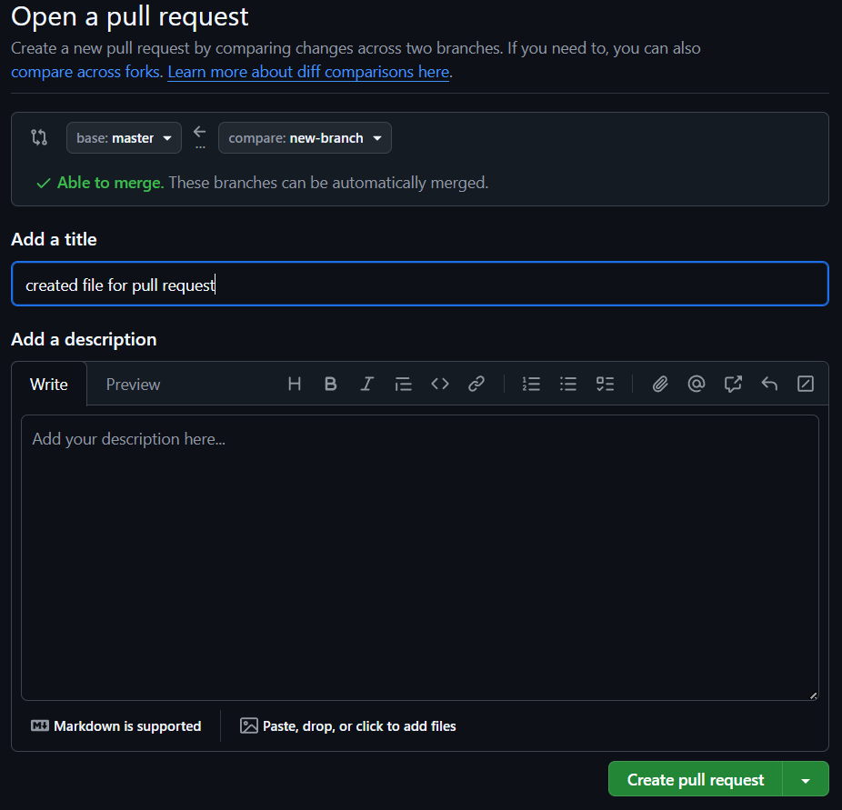

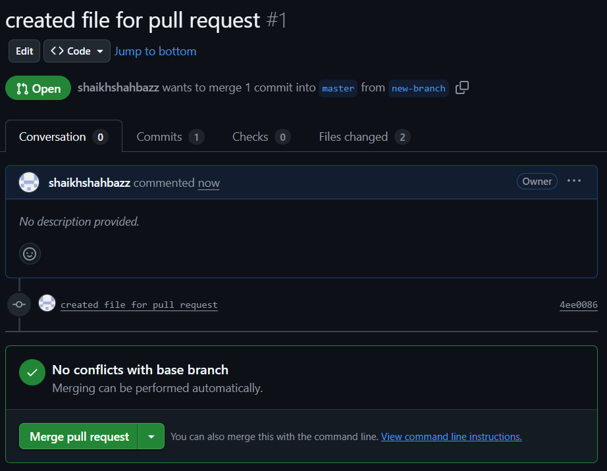

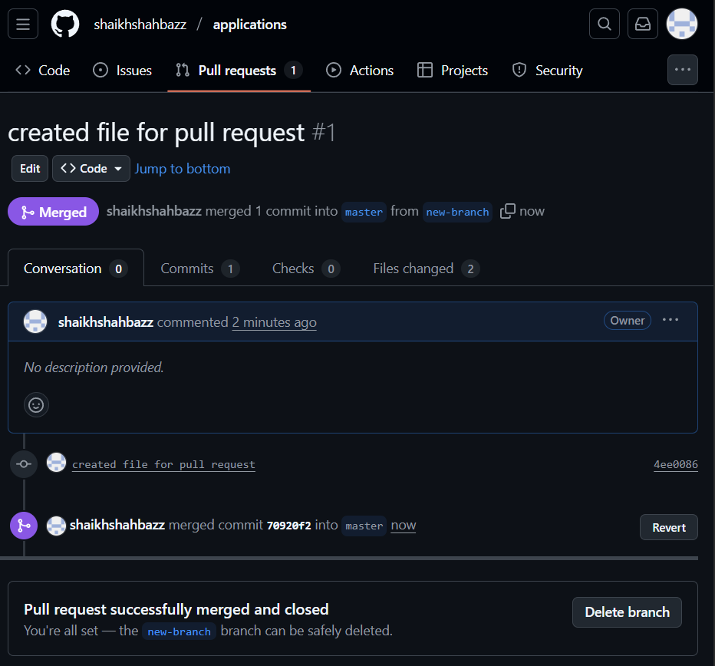

10. Create a file in local and send that to branch in github
Check which branch you are on
git branch ----- it lists all the branches you are using
Then switch to the branch where you want to send the file
git checkout sample-branch
Create a file in sample-branch
touch testfile
Then add the file to tracked area and commit the message
git add .
git commit -m “added test file to sample-branch”
Now push the file to git hub central repository
git push -u origin sample-branch

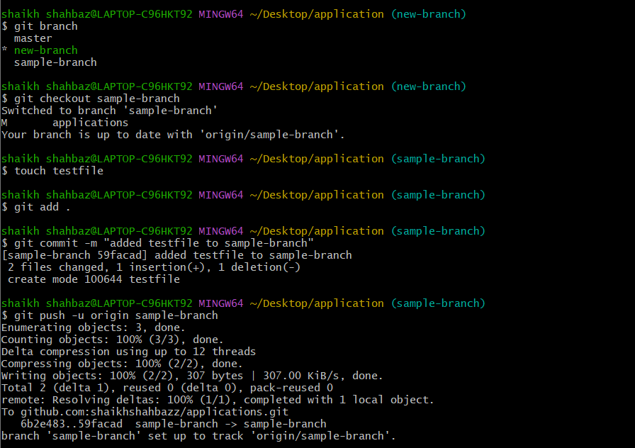

testfile is created in local sample-branch and then it is send the file to the master branch in git hub
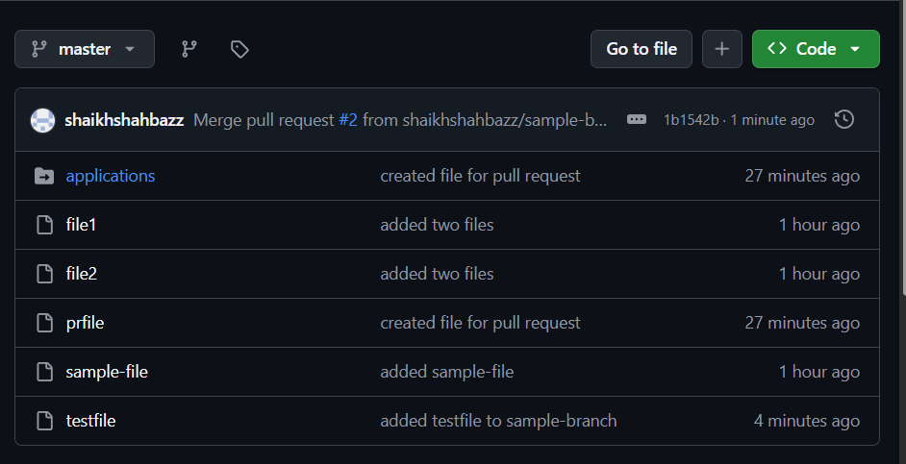

11. Clone only a branch from git hub to local
To clone only one specific branch from git hub we have a command
git clone -b new-branch --single-branch <repo url>

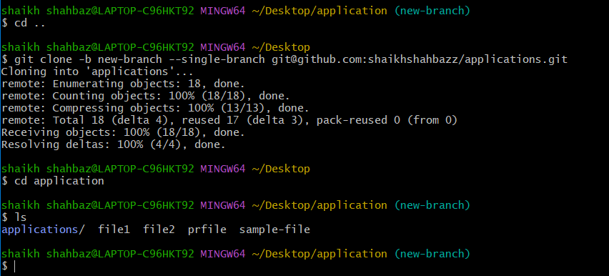
12. Create a file with all passwords and make that untrackable with git.
Create a new file and add password to it
touch password
Then create a file .gitignore
touch .gitignore
Then add passwords in .gitignore file
vi .gitignore
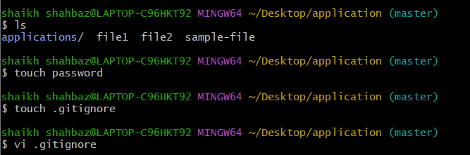
Now to make the file untracked we use
git rm --cached password ----password is a file name
Then commit the file with commit message
git commit -m “stop tracking password file”
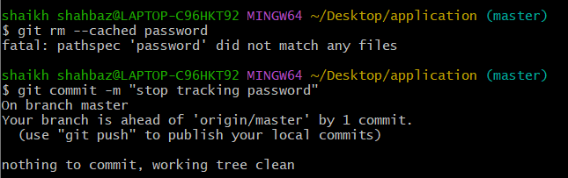

13. Make a commit and make that commit reset without making changes
First make a commit
git add .
git commit -m “my commit”
Reset the commit without making changes
git reset --soft HEAD~1 ---- soft HEAD-1 is used when we have more than 1 commits
To see the commits you have committed in the local machine
git reset --oneline

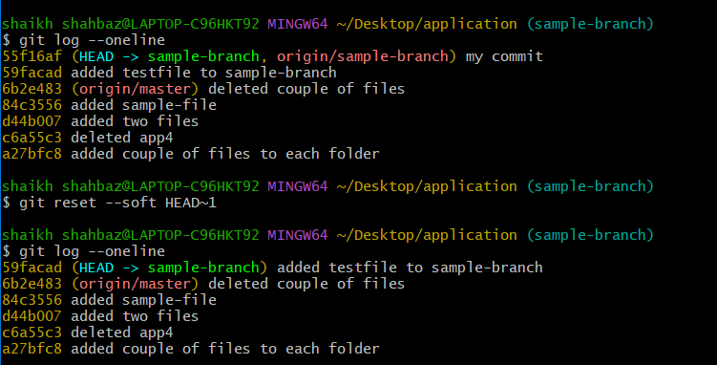

I have created a commit “my commit” and reset that commit without making changes

14. Revert the commited commit to the older version

To save your current changes safely and makes your working directory clean
git stash ----- to save current changes
git stash pops ---- to restore earlier changes
To revert the commit which you want to undo
git revert <commit id>
This shows the commit before reverting
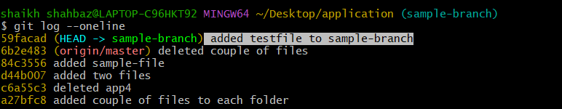
git revert <commit id> ---- then edit ---insert----
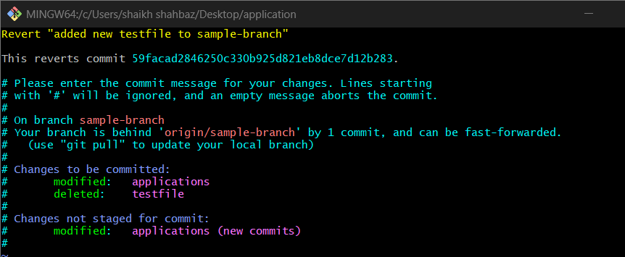
This shows the commit after reverting
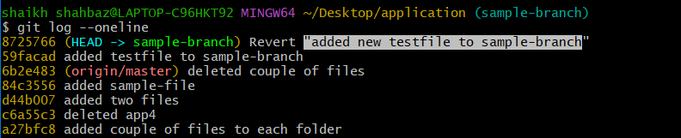

15. Push a file to stash without saving the changes and work on another file
First we will push the existing file to stash
git stash push <file name> ---- the file is stashed and hidden
then we will create one new file
You cannot stash committed files.
Stash works only for UNCOMMITTED changes.
vi file1

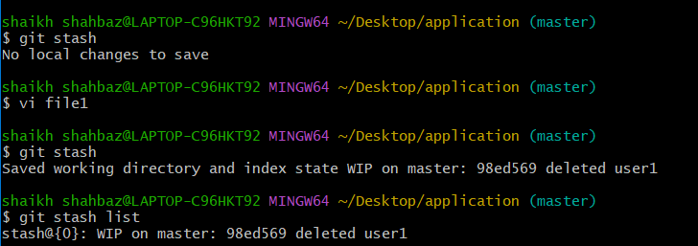

16. Undo the stash file and start working on that again
To bring back the stashed file and to start working by using
git stash pop ---- restore back to local
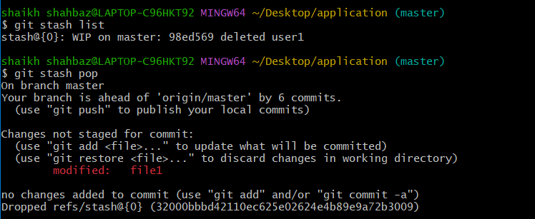
17. Generate a ssh-keygen and configure into github
To create ssh key by using ssh-keygen we use
Ssh-keygen ----- to generate ssh-keygen
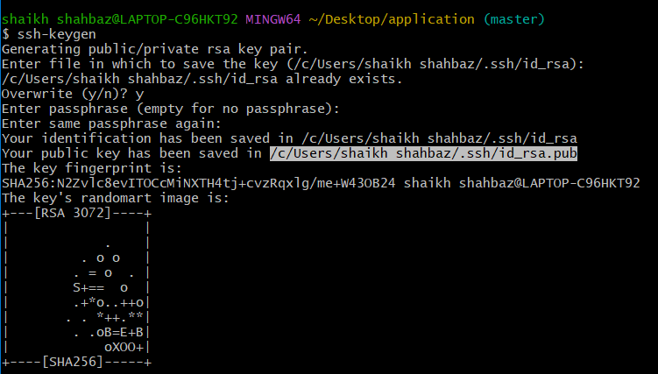

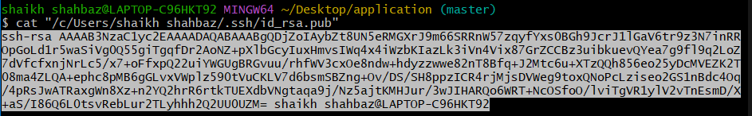
Then pasted the public key in central repository

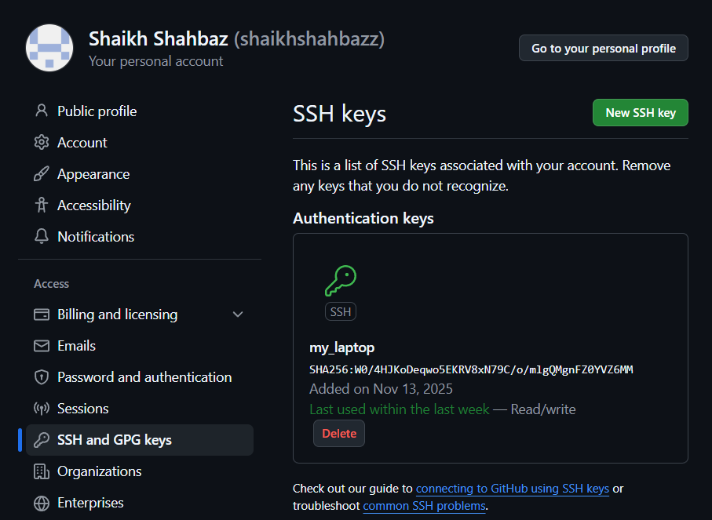
18. Basic understanding of .git file.
When you run git init inside a project, Git creates a hidden folder called .git in your project directory.
“This. git folder is the heart of your Git repository”
What does the .git folder contain?
1. HEAD
Points to the branch you are currently on.
Example: refs/heads/main
2. config
Contains Git configuration for this repository.
Example: username, email, remote URL
3. objects
Most important folder
Stores all Git data (commits, blobs/files, trees: the complete project history).
4. index
The staging area file.
Stores what is ready to be committed.
5. logs
History of operations like checkout, commit.
Why is the .git folder so important?
Because it stores the entire history of your project.
If you delete the .git folder:
Your project becomes a NORMAL folder
All history is lost

Git commands will stop working

19. Check all the logs of git.
To check all the logs of git we use
git log ------ it will display all the logs in that repository
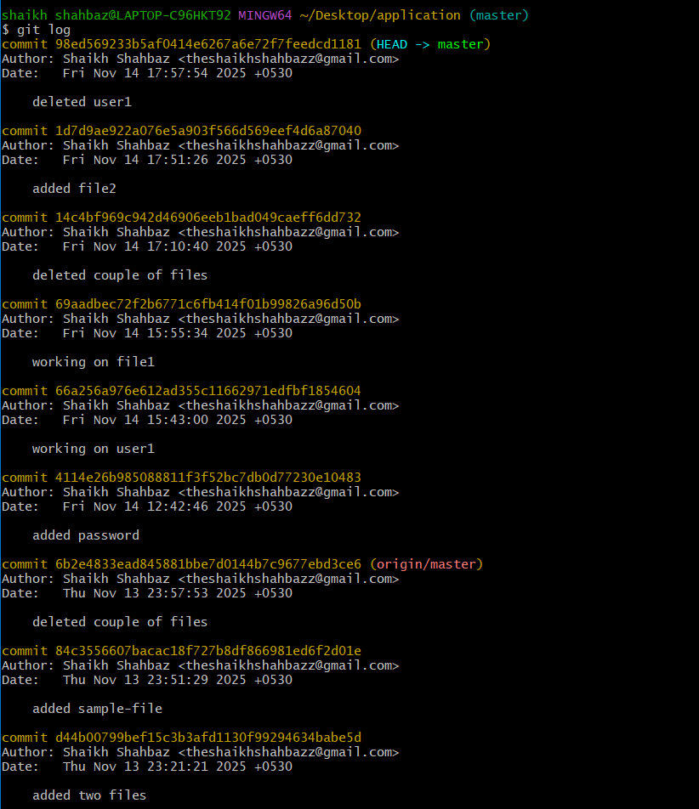
20. Rename the commit message.
To rename the commit message we can use
git commit --amend
first we can see the recent commits
git commit --oneline
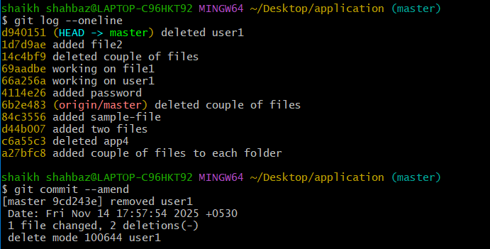

21. Merge multiple commits into single
git rebase -i HEAD~3
then in vi editor replace pick squash then :wq!
